 | 13.1.8 Editors - Shader Editor - Header - Add Menu - Shader
Table of content
Detailed table of content 1
Add menu - Shader 8
Add Shader 8
Anisotropic BSDF 9
Background 10
Diffuse BSDF 10
Emission 11
Glass BSDF 11
Glossy BSDF 12
Hair BSDF 13
Holdout 14
Mix Shader 14
Inputs 14
Outputs 15
Principled BSDF 15
Principled Hair BSDF 20
Principled Volume 27
Refraction BSDF 28
Specular BSDF 29
Subsurface Scattering 31
Toon BSDF 32
Translucent BSDF 33
Transparent BSDF 33
Sheen BSDF 34
Volume Absorption 35
Volume Scatter 35

Detailed table of content
Detailed table of content
Detailed table of content 1
Add menu - Shader 8
Add Shader 8
Inputs 8
Shaders 8
Outputs 9
Shader 9
Anisotropic BSDF 9
Inputs 9
Color 9
Roughness 9
Anisotropy 9
Rotation 9
Normal 9
Tangent 9
Properties 9
Distribution 9
Outputs 10
BSDF 10
Background 10
Inputs 10
Color 10
Strength 10
Outputs 10
Background 10
Diffuse BSDF 10
Inputs 10
Color 10
Roughness Cycles Only 10
Normal 10
Outputs 10
BSDF 10
Emission 11
Inputs 11
Color 11
Strength 11
Outputs 11
Emission 11
Glass BSDF 11
Inputs 11
Color 11
Roughness 11
IOR 11
Normal 11
Properties 11
Distribution 11
Sharp 11
GGX 11
Multiple-scattering GGX 12
Beckmann 12
Ashikhmin-Shirley 12
Outputs 12
BSDF 12
Glossy BSDF 12
Inputs 12
Color 12
Roughness 12
Normal 12
Properties 12
Distribution 12
Sharp 12
Beckmann 12
GGX 13
Ashikhmin-Shirley 13
Multiple-scattering GGX 13
Outputs 13
BSDF 13
Hair BSDF 13
Inputs 13
Color 13
Offset 13
Roughness U/V 13
Tangent 13
Properties 13
Component 13
Reflection 14
Transmission 14
Outputs 14
BSDF 14
Holdout 14
Outputs 14
Holdout 14
Mix Shader 14
Inputs 14
Shader 14
Factor 14
Outputs 15
Shader 15
Principled BSDF 15
Inputs 15
Base Color 15
Metallic 15
Roughness 15
IOR 15
Alpha 16
Normal 16
Subsurface Subtab 16
Mode Christensen-Burley 16
Weight 16
Subsurface Radius 16
Scale 16
Mode Random Walk 16
Weight 16
Subsurface Radius 16
Scale 17
Anisotropy 17
Mode Random Walk (Skin) 17
Weight 17
Subsurface Radius 17
Scale 17
IOR 17
Anisotropy 17
Specular Subtab 17
Specular Mode 17
GGX 17
Multiple-scattering GGX 17
IOR Level 18
Tint 18
Anisotropic 18
Anisotropic Rotation 18
Tangent 18
Transmission Subpanel 18
Weigth 18
Coat subpanel 18
Weight 19
Roughness 19
IOR 19
Tint 19
Normal 19
Sheen subpanel 19
Weight 19
Roughness 19
Tint 19
Emission subpanel 19
Color 19
Emission Strength 19
Thin Film subpanel 19
Thickness 20
IOR 20
Outputs 20
BSDF 20
Principled Hair BSDF 20
Properties 20
Scattering Mode 20
Chiang Model versus Huang Model 20
Color Parametrization 20
Inputs 20
Huang - Absorption coefficient 21
Absorption Coefficient 21
Aspect Ratio 21
Roughness 21
IOR 21
Offset 21
Random Roughness 21
Random 21
Reflection 21
Transmission 21
Secondary Reflection 21
Huang - Melanin concentration 22
Melanin 22
Melanin Redness 22
Tint 22
IOR 22
Offset 22
Random Color 22
Random Roughness 23
Reflection 23
Transmission 23
Secondary Reflection 23
Huang - Direct Coloring 23
Aspect Ratio 23
Roughness 23
IOR 23
Offset 23
Random Roughness 23
Reflection 23
Transmission 24
Secondary Reflection 24
Chiang - Absorption coefficient 24
Absorption Coefficient 24
Roughness 24
Radial Roughness 24
Coat 24
IOR 24
Offset 24
Random Roughness 25
Random 25
Chiang - Melanin concentration 25
Melanin 25
Melanin Redness 25
Tint 25
Roughness 26
Radial Roughness 26
Coat 26
IOR 26
Offset 26
Random Color 26
Random Roughness 26
Chiang - Direct Coloring 26
Color 26
Roughness 27
Radial Roughness 27
Coat 27
IOR 27
Offset 27
Random Roughness 27
Outputs 27
BSDF 27
Principled Volume 27
Inputs 27
Color 27
Color Attribute 27
Density 28
Density Attribute 28
Anisotropy 28
Absorption Color 28
Emission Strength 28
Emission Color 28
Blackbody Intensity 28
Blackbody Tint 28
Temperature 28
Temperature Attribute 28
Outputs 28
Volume 28
Refraction BSDF 28
Inputs 29
Color 29
Roughness 29
Normal 29
Properties 29
Distribution 29
Outputs 29
BSDF 29
Specular BSDF 29
Inputs 29
Base Color 29
Specular Color 29
Roughness 30
Emissive Color 30
Transparency 30
Normal 30
Clear coat 30
Clear coat Roughness 30
Clear coat Normal 30
Ambient Occlusion 30
Outputs 30
BSDF 30
Subsurface Scattering 31
Inputs 31
Color 31
Scale 31
Radius 31
Sharpness 31
Normal 31
Texture Blur 31
Properties 31
Falloff Method 31
Christensen-Burley 32
Random Walk 32
Cubic 32
Gaussian 32
Outputs 32
BSSRDF 32
Toon BSDF 32
Inputs 32
Color 32
Size 32
Smooth 32
Normal 33
Properties 33
Component 33
Diffuse 33
Glossy 33
Outputs 33
BSDF 33
Translucent BSDF 33
Inputs 33
Color 33
Normal 33
Outputs 33
BSDF output 33
Transparent BSDF 33
Inputs 34
Color 34
Outputs 34
BSDF 34
Sheen BSDF 34
Inputs 34
Color 34
Sigma 34
Normal 34
Properties 34
Distribution 34
Outputs 34
BSDF 34
Volume Absorption 35
Inputs 35
Color 35
Density 35
Outputs 35
Volume 35
Volume Scatter 35
Inputs 35
Color 35
Density 35
Anisotropy 35
Output 35
Volume 35

Add menu - Shader

The shader section contains the different shader nodes. The content is different for the sub modes Object, World and Line Style. And it is dependant of the chosen render engine.
Left Eevee, right Cycles:
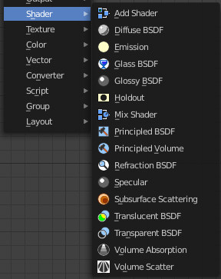
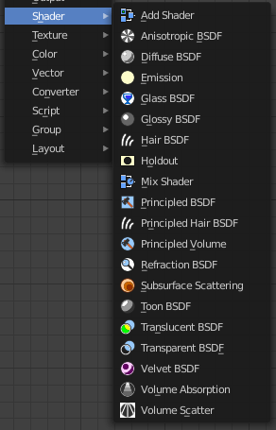

World / Line Art :
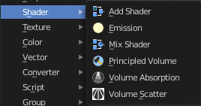
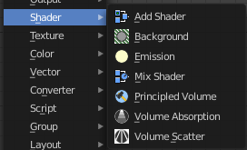

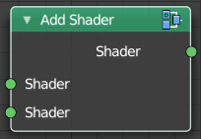
Add Shader
The Add node is used to add two Shaders together.

Inputs

Shaders
Standard shader inputs.

Outputs

Shader
Standard shader output.

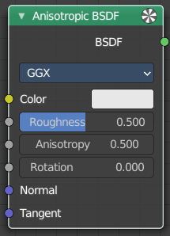
Anisotropic BSDF

Cycles Only
Adds a glossy reflection. The U and V direction roughness can be controlled separately. The tangents used for shading are derived from the active UV map. If no UV map is available, they are automatically generated using a sphere mapping based on the mesh bounding box.

Inputs

Color
Color of the surface, or physically speaking, the probability that light is reflected for each wavelength.

Roughness
Sharpness of the reflection; perfectly sharp at 0.0 and smoother with higher values.

Anisotropy
Amount of anisotropy in the reflection; 0.0 gives a round highlight. Higher values give elongated highlights orthogonal to the tangent direction; negative values give highlights shaped along the tangent direction.

Rotation
Rotation of the anisotropic tangent direction. Value 0.0 equals 0° rotation, 0.25 equals 90° and 1.0 equals 360° = 0°. This can be used to texture the tangent direction.

Normal
Normal used for shading; if nothing is connected the default shading normal is used.

Tangent
Tangent used for shading; if nothing is connected the default shading tangent is used.

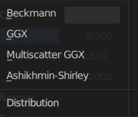
Properties

Distribution
The available Microfacet distribution methods. Beckmann, GGX and Ashikhmin-Shirley can use the Roughness input for blurry reflections.

Outputs

BSDF
Standard shader output.

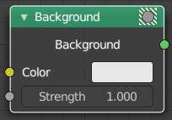
Background
Shader Type World

The Background shader node is used to add background light emission.

Inputs

Color
Color of the emitted light.

Strength
Strength of the emitted light.

Outputs

Background
Standard shader output.

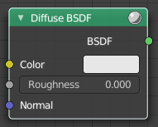
Diffuse BSDF
Shader Type Object
The Diffuse BSDF node is used to add Lambertian and Oren-Nayar diffuse reflection.

Inputs

Color
Color of the surface, or physically speaking, the probability that light is reflected or transmitted for each wavelength.

Roughness Cycles Only
Surface roughness; 0.0 gives standard Lambertian reflection, higher values activate the Oren-Nayar BSDF.

Normal
Normal used for shading; if nothing is connected the default shading normal is used.

Outputs

BSDF
Standard shader output.

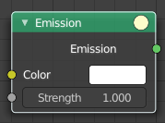
Emission
The Emission node emits light.

Inputs

Color
Color of the emitted light.

Strength
Strength of the emitted light. For point and area lights, the unit is Watts. For materials, a value of 1.0 will ensure that the object in the image has the exact same color as the Color input, i.e. make it ‘shadeless’.

Outputs

Emission
The Emission shader output can both be plugged into the Surface Input as well as the Volume Input of the Material Output node.

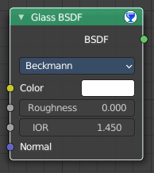
Glass BSDF
A glass shader.

Inputs

Color
Color of the surface, or physically speaking, the probability that light is transmitted for each wavelength.

Roughness
Influences sharpness of the refraction; perfectly sharp at 0.0 and smoother with higher values.

IOR
Index of refraction (IOR) defining how much the ray changes direction. At 1. 0 rays pass straight through like transparent; higher values give more refraction.

Normal
Normal used for shading.

Properties

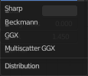
Distribution
The micro facet distribution method to use.

Sharp
Results in perfectly sharp reflections like a mirror. The Roughness value is not used.

GGX
GGX micro facet distribution.

Multiple-scattering GGX
Cycles Only
Takes multiple bounce (scattering) events between micro facets into account. This gives a more energy conserving results, which would otherwise be visible as excessive darkening.

Beckmann
Cycles Only
Beckmann micro facet distribution.

Ashikhmin-Shirley
Cycles Only
Ashikhmin-Shirley micro facet distribution.

Outputs

BSDF
Standard shader output.

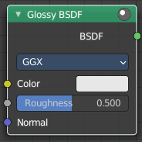
Glossy BSDF
Object sub mode only

The Glossy BSDF node is used to add reflection with micro facet distribution, used for materials such as metal or mirrors.

Inputs

Color
Color of the surface, or physically speaking, the probability that light is reflected for each wavelength.

Roughness
Input for the surface roughness resulting in sharp to blurry reflections.

Normal
Normal used for shading.

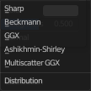
Properties

Distribution
Micro facet distribution to use.

Sharp
Results in perfectly sharp reflections like a mirror. The Roughness value is not used.

Beckmann
Cycles Only
Beckmann micro facet distribution.

GGX
GGX micro facet distribution.

Ashikhmin-Shirley
Cycles Only
Ashikhmin-Shirley micro facet distribution.

Multiple-scattering GGX
Cycles Only
Takes multiple bounce (scattering) events between micro facets into account. This gives a more energy conserving results, which would otherwise be visible as excessive darkening.

Outputs

BSDF
Standard shader output.

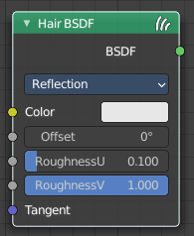
Hair BSDF
Cycles Only
The Hair BSDF node is used to add shading for Hair.

Inputs

Color
Color of the hair.

Offset
Controls the way the light is rotated (angular shift) for the reflection/transmission.

Roughness U/V
Controls the roughness in the direction light is skewed, and perpendicular to it.

Tangent
Input tangent.

Properties

Component
There are two components that can be used to control the look of the hair. Usually you are going to want each of these and use a Mix Node.

Reflection
The light that bounces off the surface of the hair.

Transmission
The light that passes through the hair and comes out the other side.

Outputs

BSDF
Standard shader output.

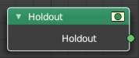
Holdout
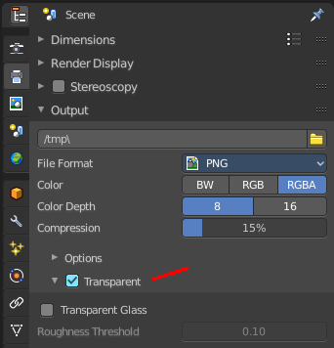
The Holdout shader node is used to create a “hole” in the image with zero alpha transparency, which is useful for compositing (see alpha channel).
Note that the holdout shader can only create alpha when Transparent is enabled. This can be found in the render settings. Properties > Render > Film > Transparent is enabled. If it is disabled, the holdout shader will be black.

Outputs

Holdout
Standard shader output.

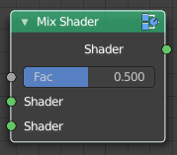
Mix Shader
The Mix node is used to mix two shaders together. Mixing can be used for material layering, where the Factor input may, for example, be connected to a Blend Weight node.

Inputs

Shader
Shaders to mix, such that incoming rays hit either with the specified probability in the Factor socket.

Factor
Blend weight to use for mixing two shaders; at zero it uses the first shader entirely and at one the second shader.

Outputs

Shader
Standard shader output.

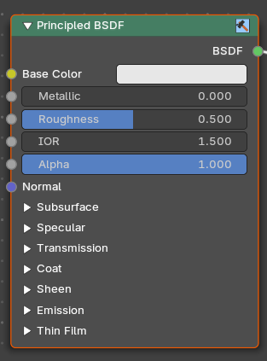
Principled BSDF

The Principled BSDF that combines multiple shader layers into a single easy to use node. It is based on the Disney principled model also known as the “PBR” shader, making it compatible with other software such as Pixar’s Renderman® and Unreal Engine®. Image textures painted or baked from software like Substance Painter® may be directly linked to the corresponding parameters in this shader.
This “Uber” shader includes multiple layers to create a wide variety of materials. The base layer is a user controlled mix between diffuse, metal, subsurface scattering and transmission. On top of that there is a specular layer, sheen layer and clear coat layer.
Note! The emphasis on compatibility with other software means that it interprets certain input parameters differently from older Blender nodes.

Inputs

Base Color
Diffuse or metal surface color.

Metallic
Blends between a non-metallic and metallic material model. A value of 1.0 gives a fully specular reflection tinted with the base color, without diffuse reflection or transmission. At 0.0 the material consists of a diffuse or transmissive base layer, with a specular reflection layer on top.

Roughness
Specifies micro facet roughness of the surface for diffuse and specular reflection.
Hint. When converting from the older Glossy BSDF node, use the square root of the original value.

IOR
Index of refraction for transmission.

Alpha
Controls the transparency of the surface, with 1.0 fully opaque. Usually linked to the Alpha output of an Image Texture node.

Normal
Controls the normals of the base layers.

Subsurface Subtab

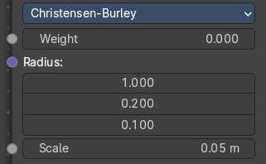
Mode Christensen-Burley
Christensen-Burley is an approximation to physically-based volume scattering. Gives less blurry results than Cubic and Gaussian functions.

Weight
Mix between diffuse and subsurface scattering. Rather than being a simple mix between Diffuse and Subsurface Scattering, it acts as a multiplier for the Subsurface Radius.

Subsurface Radius
Average distance that light scatters below the surface. Higher radius gives a softer appearance, as light bleeds into shadows and through the object. The scattering distance is specified separately for the RGB channels, to render materials such as skin where red light scatters deeper. The X, Y and Z values are mapped to the R, G and B values, respectively.

Scale
Scale of the subsurf scattering ( multiplied with radius).

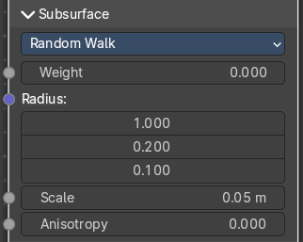
Mode Random Walk
Random Walk Provides the most accurate results for thin and curved objects. This comes at the cost of increased render time or noise for more dense media like skin, but also better geometry detail preservation. Random Walk uses true volumetric scattering inside the mesh, which means that it works best for closed meshes. Overlapping faces and holes in the mesh can cause problems.

Weight
Mix between diffuse and subsurface scattering. Rather than being a simple mix between Diffuse and Subsurface Scattering, it acts as a multiplier for the Subsurface Radius.

Subsurface Radius
Average distance that light scatters below the surface. Higher radius gives a softer appearance, as light bleeds into shadows and through the object. The scattering distance is specified separately for the RGB channels, to render materials such as skin where red light scatters deeper. The X, Y and Z values are mapped to the R, G and B values, respectively.

Scale
Scale of the subsurf scattering ( multiplied with radius).

Anisotropy
Adds some random directional light scattering.

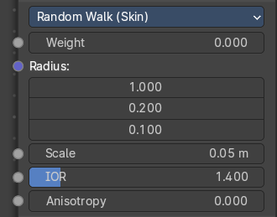
Mode Random Walk (Skin)
Random Walk Provides the most accurate results for thin and curved objects. This comes at the cost of increased render time or noise for more dense media like skin, but also better geometry detail preservation. Random Walk uses true volumetric scattering inside the mesh, which means that it works best for closed meshes. Overlapping faces and holes in the mesh can cause problems.

Weight
Mix between diffuse and subsurface scattering. Rather than being a simple mix between Diffuse and Subsurface Scattering, it acts as a multiplier for the Subsurface Radius.

Subsurface Radius
Average distance that light scatters below the surface. Higher radius gives a softer appearance, as light bleeds into shadows and through the object. The scattering distance is specified separately for the RGB channels, to render materials such as skin where red light scatters deeper. The X, Y and Z values are mapped to the R, G and B values, respectively.

Scale
Scale of the subsurf scattering ( multiplied with radius).

IOR
Adds a refraction for more realistic results.

Anisotropy
Adds some random directional light scattering.

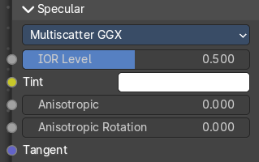
Specular Subtab

Specular Mode

GGX
A method that is faster than Multiple-scattering GGX but is less physically accurate. Selecting it enables the Transmission Roughness input.

Multiple-scattering GGX
Takes multiple bounce (scattering) events between micro facets into account. This gives a more energy conserving results, which would otherwise be visible as excessive darkening.

IOR Level
Amount of dielectric specular reflection. Specifies facing (along normal) reflectivity in the most common 0 - 8% range.
Hint. To compute this value for a realistic material with a known index of refraction, you may use this special case of the Fresnel formula: specular=((ior-1)/(ior+1))2/0.08
For example:
water: ior = 1.33, specular = 0.25
glass: ior = 1.5, specular = 0.5
diamond: ior = 2.417, specular = 2.15
Since materials with reflectivity above 8% do exist, the field allows values above 1.

Tint
Tints the facing specular reflection using the base color, while glancing reflection remains white.
Normal dielectrics have colorless reflection, so this parameter is not technically physically correct and is provided for faking the appearance of materials with complex surface structure.

Anisotropic
Amount of anisotropy for specular reflection. Higher values give elongated highlights along the tangent direction; negative values give highlights shaped perpendicular to the tangent direction.

Anisotropic Rotation
Rotates the direction of anisotropy, with 1.0 going full circle.
Hint. Compared to the Anisotropic BSDF node, the direction of highlight elongation is rotated by 90°. Add 0.25 to the value to correct.

Tangent
Controls the tangent for the Anisotropic layer.


Transmission Subpanel

Weigth
Blend between transmission and other base layers.

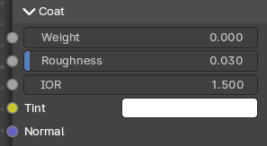
Coat subpanel
Extra white specular layer on top of others. This is useful for materials like car paint and the like.

Weight
Controls the intensity of the coat layer. Both, the reflection and the tinting. For physically based materials this value should be zero.

Roughness
Roughness of clear coat specular.

IOR
The index of refraction of the coat layer. It affects the reflectivity and the falloff of coat tinting.

Tint
The coat color. Saturation increases at shallower angles as the light travels farther through the medium.

Normal
Controls the normals of the coat layer.

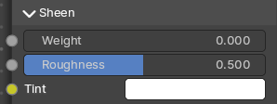
Sheen subpanel

Weight
Controls the intensity of the layer.

Roughness
Controls the roughness of the layer.

Tint
Mix between white and using base color for sheen reflection.

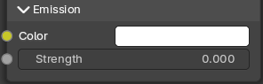
Emission subpanel
Light emission from the surface, like the Emission shader.

Color
The emission color.

Emission Strength
The strength of the light emission.

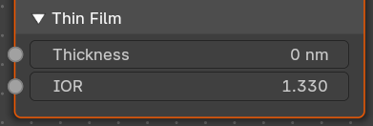
Thin Film subpanel
A thin film coating of a material with a normal angle of incidence.
Note: Useful for bubbles, oil floating on water and other similar effects.

Thickness
The thickness of the thin film

IOR
The index of refraction of the thin film layer. It affects the reflectivity and the falloff of thin film.

Outputs

BSDF
Standard shader output.

Principled Hair BSDF
Cycles Only
The Principled Hair BSDF is a physically-based, easy-to-use shader for rendering hair and fur.

Properties

Scattering Mode

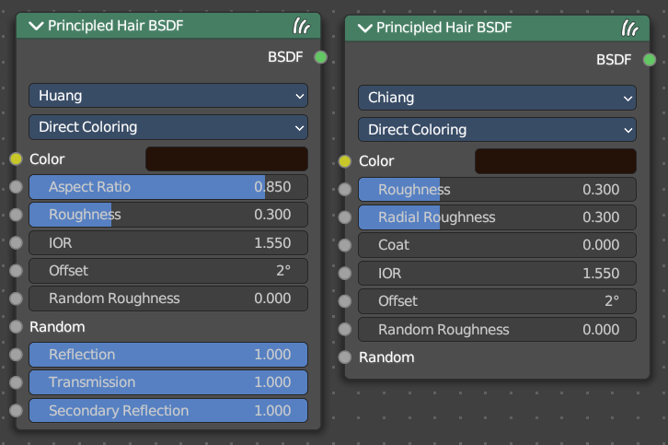
Chiang Model versus Huang Model
There are two scattering models available. Chiang and Huang. Chiang is the older model, with a less accurate result. Huang the newer model. The available options differs from model to model.
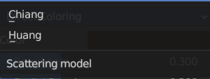

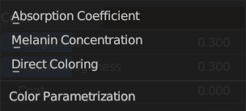
Color Parametrization
The shader provides three different ways, or parametrizations, to color the hair strands. Direct coloring, Melanin concentration and Absorption coefficient. They have some different settings and inputs.

Inputs

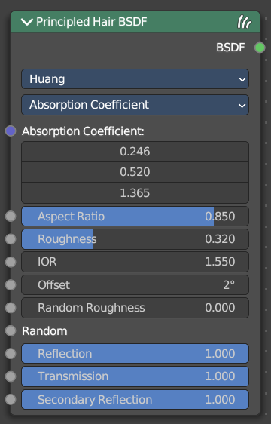
Huang - Absorption coefficient
Specifies the attenuation coefficient sa, as applied by the Beer-Lambert law. This mode is intended mainly for technical users who want to use coefficients from the literature without any sort of conversion.

Absorption Coefficient
Specifies the light absorption per unit length as the light passes through the value. A higher value leads to a darker color. The absorption coefficient is a vector 3.

Aspect Ratio
For elliptical hair cross-section the aspect ratio is the ratio of the minor axis to the major axis. The major axis is alighed with the curve normal.
Recommended values are 0.8 to 1 for asian hair, 0.654 to 0.9 for caucasian hair and 0.5 to 0.65 for african hair. Set it to 1 for a circular cross section.

Roughness
The hair roughness. A lower value leads to a metallic look.

IOR
Refraction coefficient. The default value of 1.550 is the refraction coefficient of melanin.

Offset
The tilt angle of the cuticle scales. That'st the outermost part of the hair. They are always tilted towards the hair root. Human hair has a value between 2 and 4.

Random Roughness
Adds a random roughness to each strand.

Random
Add a random input value.

Reflection
Optional factor for modulating the first light bounce off the hair surface. The color of this component is always white. Keep it 1.0 for physical correctness.

Transmission
Optional factor for modulating the transmission component. The color of this component is always white. Keep it 1.0 for physical correctness.

Secondary Reflection
Optional factor for modulating the component which is transmitted into the hair, reflected off the backside of the hair and then transmitted out of the hair. This component is oriented approximately around the incoming direction, and picks up the color of the pigment inside the hair. Keep this 1.0 for physical correctness.

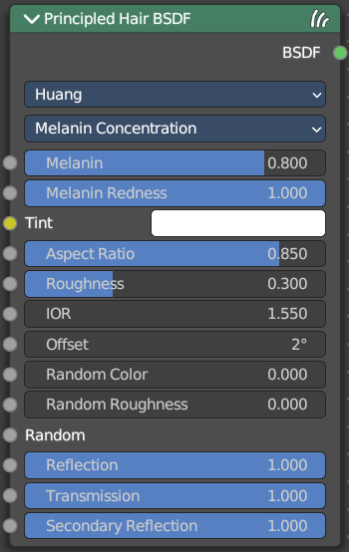
Huang - Melanin concentration
This mode defines the color as the quantity and ratio of the pigments which are commonly found in hair and fur, eumelanin (prevalent in brown-black hair) and pheomelanin (red hair). The quantity is specified in the Melanin input, and the ratio between them in Melanin Redness. Increasing concentrations darken the hair (the following are with Melanin Redness 1):
White (Melanin 0), Blonde (Melanin 0.25), Reddish (Melanin 0.5), Brown (Melanin 0.75), Black (Melanin 1)
Additionally, the Tint inputs allows to dye the hair with the desired color.

Melanin
Absolute quantity of pigment. Range [0,1] equivalent to [0%,100%].
Hint. This is a linear mapping to the underlying exponential function: melanin_qty=-ln(max(1.0-Melanin,0.0001))

Melanin Redness
Ratio of pheomelanin to eumelanin. Range [0,1] equivalent to [0%,100%].
Hint. The ratio formula is: eumelanin=Melanin*(1.0-MelaninRedness), pheomelanin=Melanin*MelaninRedness.
The resulting quantities are converted (after randomization, if specified) to absorption concentration via the following formula (section 6.1 of [EFHLA11], adjusted for the range [0,1]): sa=eumelanin*???0.5060.8411.653???+pheomelanin*???0.3430.7331.924???

Tint
Color used for dyeing the hair after applying the melanin pigment. It is not subject to randomization. It can be disabled by setting the color to white.
Hint. This is converted via the Color mapping above and added to the absorption coefficient of the melanin concentration.

IOR
Refraction coefficient. The default value of 1.550 is the refraction coefficient of melanin.

Offset
The tilt angle of the cuticle scales. That'st the outermost part of the hair. They are always tilted towards the hair root. Human hair has a value between 2 and 4.

Random Color
For each strand, vary the melanin concentration by RandomFactor. Range [0,1] equivalent to [0%,100%] of the initial melanin concentration.
Hint. The melanin concentration is multiplied by randomFactor, where randomFactor=1.0+2.0*(Random-0.5)*RandomColor.

Random Roughness
Adds a random roughness to each strand.

Reflection
Optional factor for modulating the first light bounce off the hair surface. The color of this component is always white. Keep it 1.0 for physical correctness.

Transmission
Optional factor for modulating the transmission component. The color of this component is always white. Keep it 1.0 for physical correctness.

Secondary Reflection
Optional factor for modulating the component which is transmitted into the hair, reflected off the backside of the hair and then transmitted out of the hair. This component is oriented approximately around the incoming direction, and picks up the color of the pigment inside the hair. Keep this 1.0 for physical correctness.

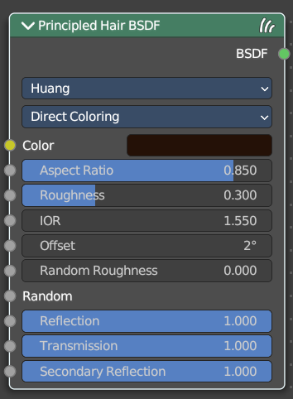
Huang - Direct Coloring
Choose the desired RGB color and the shader will approximate the necessary absorption coefficient (below).

Aspect Ratio
For elliptical hair cross-section the aspect ratio is the ratio of the minor axis to the major axis. The major axis is alighed with the curve normal.
Recommended values are 0.8 to 1 for asian hair, 0.654 to 0.9 for caucasian hair and 0.5 to 0.65 for african hair. Set it to 1 for a circular cross section.

Roughness
The hair roughness. A lower value leads to a metallic look.

IOR
Refraction coefficient. The default value of 1.550 is the refraction coefficient of melanin.

Offset
The tilt angle of the cuticle scales. That'st the outermost part of the hair. They are always tilted towards the hair root. Human hair has a value between 2 and 4.

Random Roughness
Adds a random roughness to each strand.

Reflection
Optional factor for modulating the first light bounce off the hair surface. The color of this component is always white. Keep it 1.0 for physical correctness.

Transmission
Optional factor for modulating the transmission component. The color of this component is always white. Keep it 1.0 for physical correctness.

Secondary Reflection
Optional factor for modulating the component which is transmitted into the hair, reflected off the backside of the hair and then transmitted out of the hair. This component is oriented approximately around the incoming direction, and picks up the color of the pigment inside the hair. Keep this 1.0 for physical correctness.

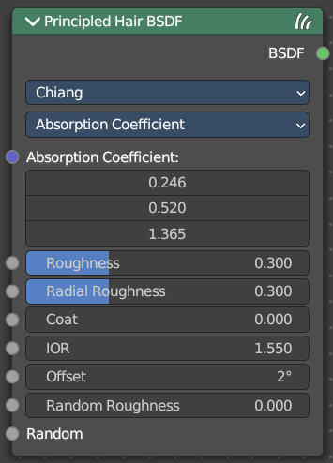
Chiang - Absorption coefficient
Specifies the attenuation coefficient sa, as applied by the Beer-Lambert law. This mode is intended mainly for technical users who want to use coefficients from the literature without any sort of conversion.

Absorption Coefficient
Specifies the light absorption per unit length as the light passes through the value. A higher value leads to a darker color. The absorption coefficient is a vector 3.

Roughness
The hair roughness. A lower value leads to a metallic look.

Radial Roughness
Specify how much the glints are smoothed in the direction of the hair tangent. Too low values will concentrate the glint; while setting it too high will spread the light across the width of the strand.
Hint. Mathematically, this parameter is mapped to the logistic distribution’s scale factor s (section 4.1 of [CBTB16]).

Coat

Simulate a shiny coat by reducing the roughness to the given factor only for the first light bounce (diffuse). Range [0, 1] is equivalent to a reduction of [0%, 100%] of the original roughness.")

IOR
Refraction coefficient. The default value of 1.550 is the refraction coefficient of melanin.

Offset
The tilt angle of the cuticle scales. That'st the outermost part of the hair. They are always tilted towards the hair root. Human hair has a value between 2 and 4.

Random Roughness
Adds a random roughness to each strand.

Random
Add a random value.

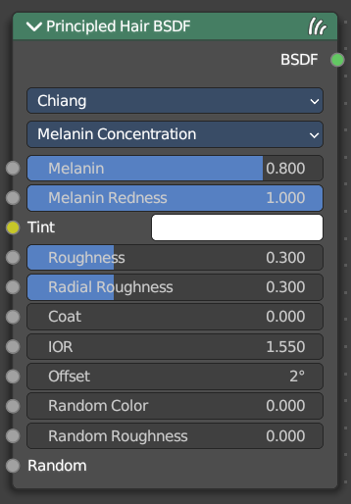
Chiang - Melanin concentration
This mode defines the color as the quantity and ratio of the pigments which are commonly found in hair and fur, eumelanin (prevalent in brown-black hair) and pheomelanin (red hair). The quantity is specified in the Melanin input, and the ratio between them in Melanin Redness. Increasing concentrations darken the hair (the following are with Melanin Redness 1):
White (Melanin 0), Blonde (Melanin 0.25), Reddish (Melanin 0.5), Brown (Melanin 0.75), Black (Melanin 1)
Additionally, the Tint inputs allows to dye the hair with the desired color.

Melanin
Absolute quantity of pigment. Range [0,1] equivalent to [0%,100%].
Hint. This is a linear mapping to the underlying exponential function: melanin_qty=-ln(max(1.0-Melanin,0.0001))

Melanin Redness
Ratio of pheomelanin to eumelanin. Range [0,1] equivalent to [0%,100%].
Hint. The ratio formula is: eumelanin=Melanin*(1.0-MelaninRedness), pheomelanin=Melanin*MelaninRedness.
The resulting quantities are converted (after randomization, if specified) to absorption concentration via the following formula (section 6.1 of [EFHLA11], adjusted for the range [0,1]): sa=eumelanin*???0.5060.8411.653???+pheomelanin*???0.3430.7331.924???

Tint
Color used for dyeing the hair after applying the melanin pigment. It is not subject to randomization. It can be disabled by setting the color to white.
Hint. This is converted via the Color mapping above and added to the absorption coefficient of the melanin concentration.

Roughness
The hair roughness. A lower value leads to a metallic look.

Radial Roughness
Specify how much the glints are smoothed in the direction of the hair tangent. Too low values will concentrate the glint; while setting it too high will spread the light across the width of the strand.
Hint. Mathematically, this parameter is mapped to the logistic distribution’s scale factor s (section 4.1 of [CBTB16]).

Coat

Simulate a shiny coat by reducing the roughness to the given factor only for the first light bounce (diffuse). Range [0, 1] is equivalent to a reduction of [0%, 100%] of the original roughness.")

IOR
Refraction coefficient. The default value of 1.550 is the refraction coefficient of melanin.

Offset
The tilt angle of the cuticle scales. That'st the outermost part of the hair. They are always tilted towards the hair root. Human hair has a value between 2 and 4.

Random Color
For each strand, vary the melanin concentration by RandomFactor. Range [0,1] equivalent to [0%,100%] of the initial melanin concentration.
Hint. The melanin concentration is multiplied by randomFactor, where randomFactor=1.0+2.0*(Random-0.5)*RandomColor.

Random Roughness
Adds a random roughness to each strand.

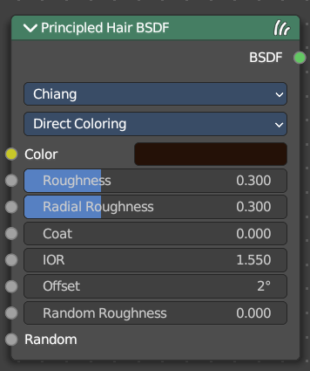
Chiang - Direct Coloring
Choose the desired RGB color and the shader will approximate the necessary absorption coefficient (below).

Color
The RGB color of the strand. Only used in Direct coloring.
Hint. The chosen color is converted to an absorption coefficient with the following formula (section 4.2 of [CBTB16]):
sa=ln(Color)(5.969-0.215ßN+2.532ß2N-10.73ß3N+5.574ß4N+0.245ß5N)2
where ßN is the radial roughness of the hair after applying randomization (if specified).

Roughness
The hair roughness. A lower value leads to a metallic look.

Radial Roughness
Add an extra radial roughness.

Coat
Simulate a shiny coat of fur, by reducing the Roughness to the given factor only for the first light bounce (diffuse). Range [0,1] equivalent to a reduction of [0%,100%] of the original Roughness.

IOR
Index of refraction (IOR) defining how much the ray changes direction. At 1.0 rays pass straight through like in a transparent material; higher values give more refraction. Default value is 1.55.

Offset
Tilts the glint of the hair by increasing the angle of the scales of the hair’s cuticle with respect to the hair shaft. Human hair usually has low values.

Random Roughness
For each strand, vary both Roughness values by RandomFactor. Range [0,1] equivalent to [0%,100%] of the initial roughness values.
Hint. The applied formula is the same one as for Random Color.

Outputs

BSDF
Standard shader output.

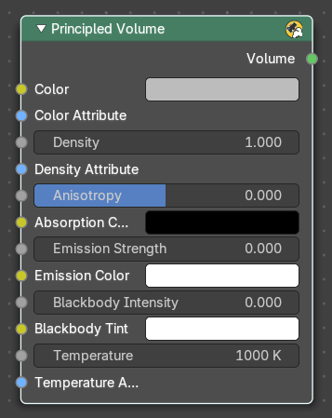
Principled Volume
The Principled Volume shader combines all volume shading components into a single easy to use node. Volumes like smoke and fire can be rendered with a single shader node, which includes scattering, absorption and blackbody emission.

Inputs

Color
Volume scattering color.

Color Attribute
Volume grid for coloring the volume. Use “color” for smoke simulations.

Density
Density of the volume.

Density Attribute
Volume grid to define the density, typically “density”.

Anisotropy
Backward or forward scattering direction.

Absorption Color
Volume shadow color tint.

Emission Strength
Amount of light to emit.

Emission Color
Emission color tint.

Blackbody Intensity
Blackbody emission for fire. Set to 1 for physically accurate intensity.

Blackbody Tint
Color tint for blackbody emission.

Temperature
Temperature in kelvin for blackbody emission, higher values emit more.

Temperature Attribute
Volume grid attribute to define the temperature.

Outputs

Volume
Standard shader output.

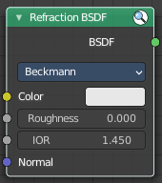
Refraction BSDF
The Refraction BSDF is used to add glossy refraction with sharp or micro facet distribution, used for materials that transmit light. For best results this node should be considered as a building block and not be used on its own, but rather mixed with a glossy node using a Fresnel factor. Otherwise it will give quite dark results at the edges for glossy refraction.

Inputs

Color
Color of the surface, or physically speaking, the probability that light is refracted for each wavelength.

Roughness
Influences sharpness of the refraction; perfectly sharp at 0.0 and smoother with higher values.

Normal
Normal used for shading; if nothing is connected the default shading normal is used.

Properties

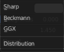
Distribution
Micro facet distribution to use. Sharp results in perfectly sharp refraction, while Beckmann and GGX can use the Roughness input for blurry refraction.

Outputs

BSDF
Standard shader output.

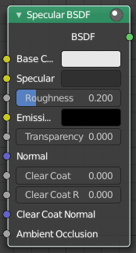
Specular BSDF
Eevee Only

The Specular BSDF combines multiple shader layers into a single easy to use node.
It is similar to the Principled BSDF node but uses the specular workflow instead of the metallic. It has far fewer parameters and supports less features. Both might be merged into one node in the future.
The specular workflow functions by specifying the facing (along normal) reflection color. The result may not be physically plausible because there is no energy conservation.

Inputs

Base Color
Diffuse surface color. For conductor materials (metals) it should be black.

Specular Color
Amount of specular reflection. Specifies facing (along normal) reflectivity. Conductor materials (metals) can have colored specular reflection.
Hint. To compute this value for a realistic material with a known index of refraction, you may use this special case of the Fresnel formula: specular=((ior-1)/(ior+1))2
For example:
water: ior = 1.33, specular = 0.25
glass: ior = 1.5, specular = 0.5
diamond: ior = 2.417, specular = 2.15

Roughness
Specifies micro facet roughness of the surface for diffuse and specular reflection.

Hint. When converting from the older Glossy BSDF node, use the square root of the original value.

Emissive Color
Color of the emitted light. This light is added to the BSDF result.

Transparency
Transparency factor. This is the inverse of the alpha channel (1 - alpha) you find in an image. Use an Invert node to convert alpha to transparency. This will only have an effect if the material uses a blend mode other than opaque.

Normal
Controls the normals of the base layers.

Clear coat
Extra white specular layer on top of others. This is useful for materials like car paint and the like.

Clear coat Roughness
Roughness of clear coat specular.

Clear coat Normal
Controls the normals of the Clear coat layer.

Ambient Occlusion
Amount of occlusion to apply to indirect lighting. Usually a bake ambient occlusion map. The final occlusion factor is the minimum of this input and the runtime ambient occlusion effect.

Outputs

BSDF
Standard shader output.

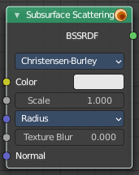
Subsurface Scattering
The Subsurface Scattering node is used to add simple subsurface multiple scattering, for materials such as skin, wax, marble, milk and others. For these materials, rather than light being reflect directly off the surface, it will penetrate the surface and bounce around internally before getting absorbed or leaving the surface at a nearby point.
How far the color scatters on average can be configured per RGB color channel. For example, for skin, red colors scatter further, which gives distinctive red-colored shadows, and a soft appearance.

Inputs

Color
Color of the surface, or physically speaking, the probability that light is reflected for each wavelength.

Scale
Global scale factor for the scattering radius.

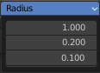
Radius
Average distance that light scatters below the surface. Higher radius gives a softer appearance, as light bleeds into shadows and through the object. The scattering distance is specified separately for the RGB channels, to render materials such as skin where red light scatters deeper. The X, Y and Z values are mapped to the R, G and B values, respectively.

Sharpness
Used only with Cubic falloff. Values increasing from 0 to 1 prevents softening of sharp edges and reduces unwanted darkening.

Normal
Normal used for shading; if nothing is connected the default shading normal is used.

Texture Blur
How much of the texture will be blurred along with the lighting, mixing the texture at the incoming and outgoing points on the surface. Note that the right choice depends on the texture. Consider for example a texture created from a photograph of skin, in this case the colors will already be pre-blurred and texture blur could be set to 0. Even for hand-painted textures, no blurring or minimal blurring might be appropriate, as a texture artist would likely paint in softening already. One would usually not even know what an unblurred skin texture looks like; we always see it blurred. For a procedural texture on the other hand this option would likely have a higher value.

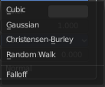
Properties

Falloff Method
Rendering method to simulate subsurface scattering.

Christensen-Burley
Is an approximation to physically-based volume scattering. Gives less blurry results than Cubic and Gaussian functions.

Random Walk
Cycles Only
Provides the most accurate results for thin and curved objects. This comes at the cost of increased render time or noise for more dense media like skin, but also better geometry detail preservation. Random Walk uses true volumetric scattering inside the mesh, which means that it works best for closed meshes. Overlapping faces and holes in the mesh can cause problems.

Cubic
Is a sharp falloff useful for many simple materials. The function is (radius-x)3.

Gaussian
Gives a smoother falloff following a normal distribution, which is particularly useful for more advanced materials that use measured data that was fitted to one or more such Gaussian functions. The function is e-8x2/radius2, such that the radius roughly matches the maximum falloff distance. To match a given measured variance v, set radius=sqrt(16×v).

Outputs

BSSRDF
BSSRDF shader output.

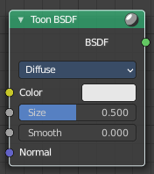
Toon BSDF
Cycles Only

The Toon BSDF is used to create Diffuse and Glossy materials with cartoon light effects.

Inputs

Color
Color of the surface, or physically speaking, the probability that light is reflected for each wavelength.

Size
Parameter between 0.0 and 1.0 that gives an angle of reflection between 0° and 90°.

Smooth
This value specifies an angle over which a smooth transition from full to no reflection happens.

Normal
Normal used for shading; if nothing is connected the default shading normal is used.

Properties

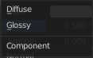
Component

Diffuse
Use shading based on the Diffuse BSDF.

Glossy
Use shading based on the Glossy BSDF for specular reflection.

Outputs

BSDF
Standard shader output.

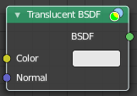
Translucent BSDF
The Translucent BSDF is used to add Lambertian diffuse transmission.

Inputs

Color
Color of the surface, or physically speaking, the probability that light is transmitted for each wavelength.

Normal
Normal used for shading; if nothing is connected the default shading normal is used.

Outputs

BSDF output
Standard shader output.

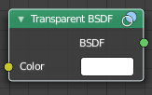
Transparent BSDF
The Transparent BSDF is used to add transparency without refraction, passing straight through the surface, as if there were no geometry there. Useful with alpha maps, for example. This shader affects light paths somewhat differently than other BSDFs. Note that only pure white transparent shaders are completely transparent.

Inputs

Color
Color of the surface, or physically speaking, the probability for each wavelength that light is blocked or passes straight through the surface.

Outputs

BSDF
Standard shader output.

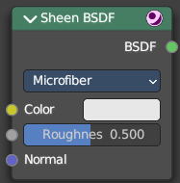
Sheen BSDF
Cycles Only

The Sheen BSDF is used to add reflection to materials such as cloth. It is meant to be used together with other shaders (such as a Diffuse Shader) and is not particularly useful on its own.

Inputs

Color
Color of the surface, or physically speaking, the probability that light is reflected for each wavelength.

Sigma
Variance of the normal distribution, controlling the sharpness of the peak. It can be thought of as a kind of roughness.

Normal
Normal used for shading; if nothing is connected the default shading normal is used.

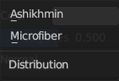
Properties

Distribution
The distribution algorithm. Akishikmin is the legacy model. Microfiber the modern approach.

Outputs

BSDF
Standard shader output.

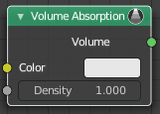
Volume Absorption
The Volume Absorption node allows light to be absorbed as it passes through the volume. Typical usage for this node would be water and colored glass.

Inputs

Color
Color of the volume.

Density
The density of the absorption effect.

Outputs

Volume
The Volume Shader.

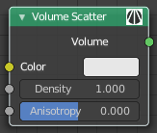
Volume Scatter
The Volume Scatter node allows light to be scattered as it passes through the volume. Typical usage would be to add fog to a scene. It can also be used with the Volume Absorption node to create smoke.

Inputs

Color
Color of the volume.

Density
The density of the scatter effect.

Anisotropy
Controls the look of the scatter effect depending on the direction of the light passing through it.

Output

Volume
The Volume Shader output must be plugged into the Volume Input of the Material or World Output node.

